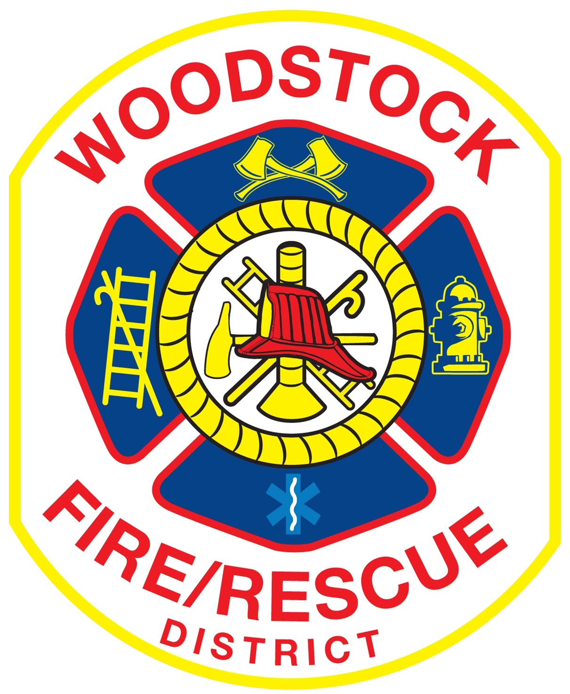
Woodstock Fire/Rescue District

435 E. Judd St., Woodstock, Illinois (815) 338-2621

News Release: Woman Airlifted After Vehicle Incident – 08/22/25

News Release

On Friday, August 22, 2025, at 6:37 p.m., the Woodstock Fire/Rescue District responded to the 100 block of 1st Street in Woodstock for a reported crash with injuries. Paramedics arrived and located an elderly woman lying in the roadway with serious injuries. Due to the extent of her injuries, a medical helicopter was requested and landed at the scene. She was then airlifted to a Rockford hospital for further treatment.

Preliminary information provided to paramedics indicated that the injuries occurred as the woman was exiting a vehicle. No other injuries were reported. The Woodstock Police Department is handling the investigation, and any additional information regarding the circumstances of the incident should be directed to them.

###

